Julia Sets WE NEED DIAGRAMS
Example 1
Choose a complex numberand look at the sequence:
… where
If we choose:

We get:
…
If we choose:

We get:
...

Ifthentends to infinity astends to infinity.
Ifthendoes not tend to infinity astends to infinity.

We could colour the number plane.
is in the red region ifandis in the blue region if
The Julia set is the boundary between the red region and the blue region.
A circle.
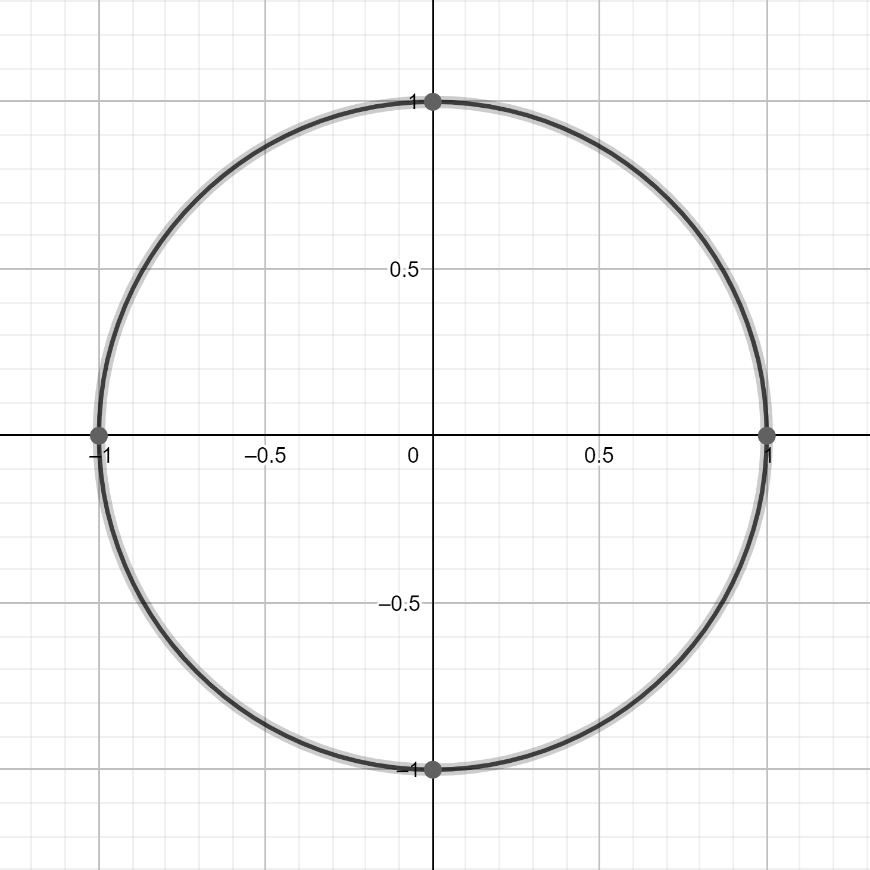

So far, so boring ...

Example 2
Choose a complex numberand look at the sequence:
… where
For some values ofwe findtends to infinity astends to infinity.
For other vales ofwe finddoes not tend to infinity astends to infinity.

We could colour the number plane.
is in the red region iftends to infinity astends to infinity.
is in the blue region ifdoes not tend to infinity astends to infinity.
The Julia set is the boundary between the red region and the blue region.
A slightly deformed circle.

WE NEED A DIAGRAM

So far, so slightly interesting ...

In general:
Choose a complex numberand look at the sequence:
… where
Look at the Julia set for different values ofThe results are truly amazing.

WE NEED DIAGRAMS

